1.Introduction

1.1 Background:
Our project stems from the people who face problems in drawing, and verifying the digital circuits. The project is built using the Object Oriented techniques. Everything in this simulator is modeled as an Object. There are some classes that lie as the root of this software. There are inbuilt Gates such as AND, OR, NOT, NAND, NOR, XOR etc. The DC and CLOCK are the objects for the input. Any digital component can be picked up by the user and can be placed in the Drawing Pad. Using the simulate button, the circuit can be simulated to see the output of the object. Equation to Circuit will transform the Boolean equations into digital circuits. Also the truth table builder will produce the truth table for any circuit drawn. The aim of the project is to make construction and simulation of the digital circuits an easy task.

1.2 Motivation:
The simulator was created mainly to ease the construction and working of the digital circuits. Use of gates is indispensable in the creation of digital circuits and our software will truly be a helping hand in construction and testing of digital circuits. We thought that a simple truth table builder, equation to circuit drawing, equation minimization etc. are some of the features that would be of help in construction of digital circuits and this was the reason for which the software was modeled.

1.3 Type of Users
1.3.1 Students:
This tool was mainly developed for students. This makes learning of the basics of Digital Electronics a very easy and interesting task.

1.3.2 Electronic Hobbyists:
Electronic Hobbyists can use this to develop innovative circuits and test their accuracy and efficiency. Moreover this is also a cost effective way for people of this kind to try their creativity in the circuit designing and developing art.

1.3.3 Testing Circuits:
As this is a dynamic simulator, this can be used efficiently for testing circuits.

1.4 Digital Circuits – Introduction
Digital circuits are electronic circuits based on a number of discrete voltage levels. In most cases there are two voltage levels: one near to zero volts and one at a higher level depending on the supply voltage in use. Circuits and mechanisms were built to represent fixed mathematical problems with results appearing in the form of a final voltage or a rotation angle of a gear.

The electrical and mechanical equivalents of addition, multiplication, integration, and differentiation were incorporated into these computers. Complex problems could be solved, albeit with the accuracy problems mentioned above. By representing mathematical quantities in a number system having only two digits--a binary number system--any value can be represented with arbitrary accuracy by linking together a sequence of two-state devices and setting the appropriate state for each device.

Logic gates are the basic elements that make up the Digital Systems. They operate on binary inputs in order to perform any logical function. The type of gate available for performing these calculations are NOT,AND,OR,NAND,NOR and XOR(exclusive-OR). By connecting different gates in different ways, we can build circuits for performing arithmetic calculations and other functions

1.4.1 Simulator
A device, computer program, or system, which duplicates the essential features of a task situation and provides a physical model. It can also be referred as a piece of equipment, which represents some major aspects of the equipment's operation.

1.4.2 API & Framework
A software framework defines the architecture for a family of sub systems and provides the basic building blocks to create them. It also defines the places where adaptations for specific functionality should be made. It consists of set of cooperating classes that make up reusable design for specific class of software. In an object oriented environment a framework consists of abstract and concrete classes. Instantiation of such a framework
consists of composing and sub classing the existing classes.

2.System Requirements

2.1 Hardware Requirements:

Processor | Pentium III, 650 MHz
Ram | 128 MB
Monitor | 15” with 32 bit color
Mouse | PS / 2 Mouse
HDD | 40 GB
CD Drive | 52X CDROM
Floppy Drive | 1.44 MB FDD
Table: 2.1 – Hardware Requirements

2.2 Software Requirements:
Operating System | Windows 2000, Linux 8.x and above
Domain / Language | Sun Java , Prolog
Tools / Libraries | JDK 1.4, xstream, gnuprolog
Runtime | Java Runtime Environment – JRE 1.4
Table: 2.2 – Software Requirements

3. System Analysis

3.1 Existing System

Digital simulators were developed with the aim of reducing complexity of building electronic devices. There are two main existing simulators they are xlogic circuits, LogicSim. These two simulators vary each other in wide range.

3.1.1 XLOGIC Circuits:
This is one is a tool which supports dynamic simulation of circuits. Its process is to build logic gates, which are circuits that compute basic logical operations such as AND, OR, and NOT. In fact, once AND, OR, and NOT gates are available, a computer could be assembled entirely from such gates. This software works with simulated circuits made up of AND, OR and NOT gates. In the XLogic Circuits applet, circuits are constructed from AND gates, OR gates, and NOT gates. Each type of gate has a different rule for computing its output value. Circuits are laid out on a circuit board. Besides gates, the circuit board can contain Inputs, Outputs, and Tacks. Wires can interconnect all these components. To the left of the circuit board in the applet is a palette. The palette contains components available to be used on the circuit board. All the components cannot be seen at once, but there is a scroll bar that allows users to scroll through all the components on the palette. Power to the circuit board is turned on and off using the "Power" checkbox below the circuit board. Checkbox is used to turn on the power .A pop-up menu that can be used to control the speed at which signals propagate through the circuit. The speed is ordinarily set to "Fast." The pop-up menu can be used to change the speed to "Moderate" or "Slow" if the user wants to watch the circuit in slow motion. Every expression of Boolean algebra corresponds to a logic circuit. The letters used in the expression are represented by the Inputs to the circuit.
As soon as the letters in an expression are assigned values true or false, the value of the entire expression can be computed. Every expression of Boolean algebra corresponds to a logic circuit. The letters used in the expression are represented by the Inputs to the circuit. Each wire in the circuit represents some part of the expression. A gate takes the values from its input wires and combines them with the appropriate word -- and, or, or not -- to produce the label on its output wire. The final output of the whole circuit represents the expression as a whole.
The circuit as a whole corresponds to the final output expression. This expression in turn serves as a blueprint for the circuit. It can be used as a guide for building the circuit. It can have only two outputs. To sum up, given any expression of Boolean algebra, a circuit can be built to compute that expression. On clicking the “Iconify" button at the bottom of the applet, the "Basic Gates" circuit is generated, by turning it into an icon on the palette and a clear circuit board can be obtained. To add a component to the circuit, click on the component and drag the component onto the circuit board. Any component can be deleted by selecting the component and clicking on the delete button.

3.1.2 LogicSim
Circuits can be selected from the list on the left side and place them on the work panel. For connection click on an output of a circuit (right side) and draw the wire to an input of a with the DEL key. The user can change settings on some circuits (clock, Flip Flop, LCD, etc). It can generate circuits from AND gate, OR gate, NOT gate, NOR gate, AND gate, XOR gate.
Circuits and Wires can be activated by clicking on them and then deleted selecting "Properties" in their context-menus. It is possible to change the number of inputs for some circuits (AND, OR, XOR, etc) with combo box below the circuits list. With the "input inverter" user can invert the level of a wire at the input of a circuit. To place the inverter, select it from the list and click on a circuit input. An input can be set to a defined level by using "input high" and "input low", without having to connect a wire to it. To reset an input to normal behavior, use "normal input" on it. It can have from 2 to 3 inputs.

3.1.2.1 Module Creation
A module contains a complete LogicSim circuit system that can be used as a single circuit element. On selecting “Create Module” from the “Module” menu it can be created “Module Label” is the label on the module symbol. After pressing the “Use” button an “input” and an “output” circuit will appear. These represent the module inputs/outputs. Switches are connected to the “INPUT” and LED's to the “OUTPUT” element to test the module. After saving the module using the save button, it will appear in the circuits list and can be used in a new circuit.

3.2 Need for Jlogics:

The basic need of simulators can be understood by its application in many fields. They have been useful not only for the developers but also for the people in the field of research. The Existing Simulators of Digital circuits provide many utilities for all types of users. Though they have many useful features they lack in certain areas, which has been incorporated in Jlogics.

On comparing Jlogics with the working of LogicSim, Jlogics offers more comfort. In LogicSim, the gates are selected and placed. It can have from only 2 to 3 inputs whereas Jlogics can have up to 32 inputs. In the case of Xlogic the working is similar to that of Jlogics except that it can compute basic logical operations such as AND, OR, and NOT.

3.3 Jlogics
Jlogics is both a simulator and framework, which has incorporated many useful features in it. It is a generic API. Like the existing simulators it has features like Dynamic Simulation, GUI, Open/Save Environment, Platform Independence and the Programming language is Java.

The Localization is made in order to make the user to feel more comfortable in using the software. Since the software is basically learning software through localization it can be easily made understood by the user. It is made available in two languages, English and Tamil. The user can select either of the one. All the menu options and the labels of the circuit appear based on the language selected.

Jlogics provides a facility that the user can reuse the existing or previously created circuit. If a new circuit has the same features with a slight modification then the user can extend the existing circuit without repeating. Thus it saves time.

Any project is validated including the Display time and Execution time. In Jlogics the symbols selected from the Menu will appear immediately and by means of the Drag and Drop facility the circuits can be constructed easily. In addition to this the circuit can be aligned by selecting the align option from the file menu. It also has an additional feature of verifying the generated circuits.

Unlike the other simulators Jlogics provides up to 32 inputs. It can generate circuits for all the basic gates such as AND, OR, NOT, NOR, NAND, XOR.

3.4 Java programming language:
Java is an object-oriented programming language developed initially by James Gosling and colleagues at Sun Microsystems. The language, initially called Oak (named after the oak trees outside Gosling's office), was intended to replace C++, although the feature set better resembles that of Objective C. Sun Microsystems currently maintains and updates Java regularly.

3.4.1 History
Java was developed in 1991 by James Gosling and other Sun engineers, as part of the Green Project. After first being made public in 1994, it achieved prominence following the announcement at 1995's SunWorld that Netscape would be including support for it in their Navigator browser.

3.4.2 Overview
There were four primary goals in the creation of the Java language:
- It should use the object-oriented programming methodology.
- It should allow the same program to be executed on multiple computer platforms.
- It should contain built-in support for using computer networks.
- It should be designed to execute code from remote sources securely.

3.4.3 Language characteristics

3.4.3.1 Object orientation
The first characteristic, object orientation ("OO"), refers to a method of programming and language design. Although there are many interpretations of OO, one primary distinguishing idea is to design software so that the various types of data it manipulates are combined together with their relevant operations. Thus, data and code are combined into entities called objects. An object can be thought of as a self-contained bundle of behavior (code) and state (data). The principle is to separate the things that change from the things that stay the same; often, a change to some data structure requires a corresponding change to the code that operates on that data, or vice versa. This separation into coherent objects provides a more stable foundation for a software system's design. The intent is to make large software projects easier to manage, thus improving quality and reducing the number of failed projects.

3.4.3.2 Platform independence
The Look and Feel of a Java GUI is independent of the platform it is running on the second characteristic, platform independence, means that programs written in the Java language must run similarly on diverse hardware. One should be able to write a program once and run it anywhere. This is achieved by most compilers by compiling the Java language code "halfway" to bytecode—simplified machine instructions specific to the Java platform. The code is then run on a virtual machine (VM), a program written in native code on the host hardware that translates generic Java bytecode into usable code on the hardware. Further, standardized libraries are provided to allow access to features of the host machines (such as graphics, threading and networking) in unified ways.

3.4.3.3 Automatic garbage collection
Java has the feature of automatic garbage collection. Objects are created and placed at an address on the heap. The program or other objects can reference an object by holding a reference to its address on the heap. When no references to an object remain, the Java garbage collector automatically deletes the object, freeing memory and preventing a memory leak.

3.4.3.4 Interfaces and classes
One thing that Java accomodates is creating an interface which classes can then implement. The feature is a result of compromise. The designers of Java decided not to support multi-inheritance but interfaces can be used to simulate multi-inheritance in some occasions.

3.4.3.5 Encoding independence
The language distinguishes between bytes and characters. Characters are stored internally using UTF-16, and Java program source may contain any Unicode character.

3.4.3.6 APIs
Sun has defined three platforms targeting different application environments and segmented many of its APIs so that they belong to one of the platforms. The platforms are:
- Java 2 Platform, Micro Edition — targeting environments with limited resources,
- Java 2 Platform, Standard Edition — targeting workstation environments
- Java 2 Platform, Enterprise Edition — targeting large distributed enterprise or internet environments.
The classes in the Java APIs are organized into separate groups called packages. Each package contains a set of related interfaces, classes and exceptions. Refer to the separate platforms for a description of the packages available.
The set of APIs is controlled by Sun Microsystems in cooperation with others through its Java Community Process program. Companies or individuals participating in this process can influence the design and development of the APIs, but Sun retains ownership and control of the APIs. This process has been a subject of controversy.

3.4.3.7 Java Runtime Environment
The Java Runtime Environment or JRE is the software required to run any application deployed on the Java platform. End-users commonly use a JRE in software packages and plug-ins. Sun also distributes a superset of the JRE called the Java 2 SDK (more commonly known as the JDK), which includes development tools such as the Java compiler, Javadoc, and debugger.

3.4.3.8 Components of the JRE
Java libraries - which are the compiled byte codes of source developed by the JRE implementor to support application development in Java. Examples of these libraries are:
The core libraries, which include:
- Collection libraries which implement data structures such as lists, dictionaries, trees and sets
- XML Parsing libraries
- Security
- Internationalization and Localization libraries
- The integration libraries, which allow the application writer to communicate with external systems. These libraries include:
- The Java Database Connectivity (JDBC) API for database access
- Java Naming and Directory Interface (JNDI) for lookup and discovery
- RMI and CORBA for distributed application development
- User Interface libraries, which include:
- The (heavyweight, or native) Abstract Windowing Toolkit (AWT), which provides GUI components, the means for laying out those components and the means for handling events from those components
- The (lightweight) Swing libraries, which are built on AWT but provide (non-native) implementations of the AWT widgetry
- APIs for audio capture, processing, and playback
- A platform dependent implementation of Java virtual machine (JVM) which is the means by which the byte codes of the Java libraries and third party applications are executed
- Plugins, which enable applets to be run in web browsers
- Java Webstart, which allows Java applications to be efficiently distributed to end users across the Internet
- Licensing and documentation

3.5 Why java and advantages:
For jLogics, we had planned to use Java as our Domain programming language, because jLogics is constructed based on Object Orientation Concept, so necessarily an OOPS language is better, also, it needs wide operation on graphics and fast rendering. The software should also work with most of the possible platforms with the equal quality. Also, since it is an education tool, it should reach people around the world and so web application support is also necessary. The above requirements are necessary for our software hence; we had opted for Java as our core programming language for jLogics.

Java supports the developer with
- Object Orientation Concepts
- In built graphical packages
- Platform Independency support
- Web application such as Applet support
- Localization support with font encoding

3.6 What is XML
The Extensible Markup Language (XML) is a W3C recommendation for creating special-purpose markup languages. It is a simplified subset of SGML, capable of describing many different kinds of data. Its primary purpose is to facilitate the sharing of structured text and information across the Internet. Languages based on XML (for example, RDF, RSS, MathML, XSIL and SVG) are themselves described in a formal way, allowing programs to modify and validate documents in these languages without prior knowledge of their form.

3.6.1 Why XML
The features of XML that make it particularly appropriate for the usage in jLogics:
- Platform independent
- Huge number of parsers available
- The ability to represent the most general computer science data structures (records, lists and trees)
- Simultaneously human- and machine-readable format
- Support for Unicode representing all current and many historical character sets
- The format is self-documenting in that it describes the structure and field names as well as specific values

Since jLogics uses XML system of representation for storing the circuits and modules, it’s easy to retrieve back the circuits and modules, with out any loss in data. Also, the XML file format can be made work in any platform and any other software can also, recognize the file format and can made render the circuit in their application.

4. System Design

4.1 About UML
Unified Modeling Language (UML) is a non-proprietary, third generation modeling and specification language. However, the use of UML is not restricted to software modeling. It can be used for modeling hardware (engineering systems) and is commonly used for business process modeling and organizational structure modeling. The UML is an open method used to specify, visualize, construct and document the artifacts of an object-oriented software-intensive system under development. The UML represents a compilation of "best engineering practices" which have proven successful in modeling large, complex systems, especially at the architectural level.

UML integrates the concepts of Booch, OMT, OOSE and Class-Relation by fusing them into a single, common and widely usable modeling language. UML aims to be a standard modeling language which can model concurrent and distributed systems.

UML is an industry standard, created under the auspices of the Object Management Group (OMG). OMG had called for information on object-oriented methodologies that might create a rigorous software modeling language. Many industry leaders had responded in earnest to help create the standard.

There are three prominent models of the UML system development:
- Functional Model
Showcases the functionality of the system from the user's Point of View. Includes Use Cases Diagrams.
- Object Model
Showcases the structure and substructure of the system using objects, attributes, operations, and associations. Includes Class Diagrams.
- Dynamic Model
Showcases the internal behaviour of the system. Includes Sequence Diagrams, Activity Diagrams, and Statechart Diagrams.

It is important to distinguish between a UML model, and a UML diagram, or set of diagrams, including Use Case Diagram, Collaboration Diagram, Activity Diagram, Sequence Diagram, Deployment Diagram, Component Diagram, Class Diagram, StateChart Diagram—a UML diagram is a graphical representation of the information in the model, but the model exists independently.

4.2 Application Framework:
Circuit API
IC Module
Circuit
Gates
Flip Flops
Circuit Simulation Engine
Additional Inbuilt Circuit Library
Graphical User Interface
Persistence Storage
Figure 4.1 – Application Framework

Circuit API is the most basic underlying API which is used for construction of gates, circuits, and simulation etc. The API is used for the simulation. The simulation engine takes circuits constructed using Circuit API and performs dynamic simulation according to the user interaction. Additional Inbuilt circuit library such as Flip-Flops etc can also be interfaced. The GUI is used to interface between the Simulation Engine and the Persistence Storage.

4.3 Use case diagram:
4.3.1 About Use case diagrams:
UML Use Case Diagrams can be used to describe the functionality of a system in a horizontal way. That is, rather than merely representing the details of individual features of your system, UCDs can be used to show all of its available functionality. It is important to note, though, that UCDs are fundamentally different from sequence diagrams or flow charts because they do not make any attempt to represent the order or number of times that the systems actions and sub-actions should be executed.

UCDs have only 4 major elements: The actors that the system described interacts with, the system itself, the use cases, or services, that the system knows how to perform, and the lines that represent relationships between these elements.

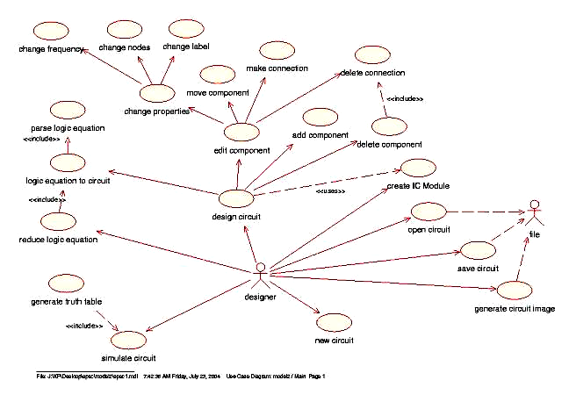
Figure 4.2 – jLogics Use case Diagram

4.4 State activity diagram:
4.4.1 About State diagrams:
State diagrams used to demonstrate the behavior of an object through many use cases of the system. State diagrams are used for classes where it is necessary to understand the behavior of the object through the entire system. Not all classes will require a state diagram and state diagrams are not useful for describing the collaboration of all objects in a use case. State diagrams are combined with other diagrams such as interaction diagrams and activity diagrams.

State diagrams have very few elements. The basic elements are rounded boxes representing the state of the object and arrows indicting the transition to the next state. The activity section of the state symbol depicts what activities the object will be doing while it is in that state.
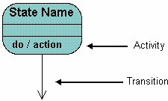
Figure 4.3 – State Diagram-1
All state diagrams begin with an initial state of the object. This is the state of the object when it is created. After the initial state the object begins changing states. Conditions based on the activities can determine what the next state the object transitions to.
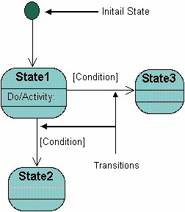
Figure 4.4 – State Diagram-2
Below is an example of a state diagram might look like for an Order object. When the object enters the Checking state it performs the activity "check items." After the activity is completed the object transitions to the next state based on the conditions [all items available] or [an item is not available]. If an item is not available the order is canceled. If all items are available then the order is dispatched. When the object transitions to the Dispatching state the activity "initiate delivery" is performed. After this activity is complete the object transitions again to the Delivered state.
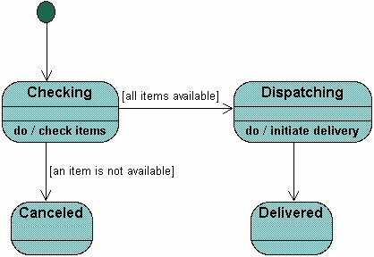
Figure 4.5 – State Diagram-3
State diagrams can also show a super-state for the object. A super-state is used when many transitions lead to a certain state. Instead of showing all of the transitions from each state to the redundant state a super-state can be used to show that all of the states inside of the super-state can transition to the redundant state. This helps make the state diagram easier to read.
The diagram below shows a super-state. Both the Checking and Dispatching states can transition into the Canceled state, so a transition is shown from a super-state named Active to the state Cancel. By contrast, the state Dispatching can only transition to the Delivered state, so we show an arrow only from the Dispatching state to the Delivered state.

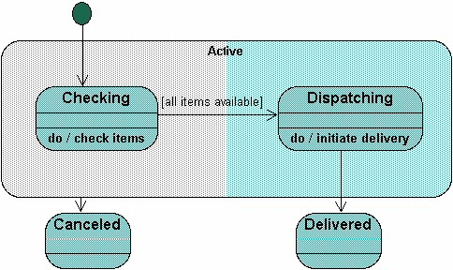
Figure 4.6 – State Diagram-4
Activity for Open a circuit and editing
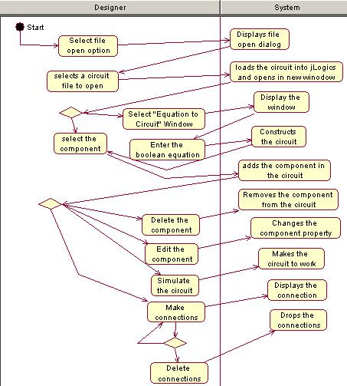

Figure 4.7- Activity for Open a circuit and editing

Activity Diagram for Equation to circuit conversion and editing

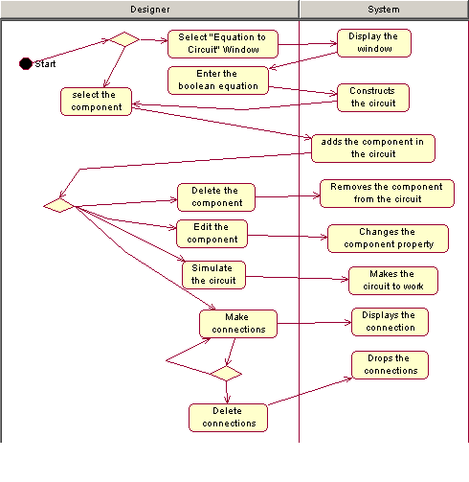
Figure 4.8 - Activity Diagram for Equation to circuit conversion and editing

4.5 Class Diagrams:
4.5.1 About Class diagrams:
Class diagrams are widely used to describe the types of objects in a system and their relationships. Class diagrams model class structure and contents using design elements such as classes, packages and objects. Class diagrams describe three different perspectives when designing a system, conceptual, specification, and implementation. These perspectives become evident as the diagram is created and help solidify the design. This example is only meant as an introduction to the UML and class diagrams. Classes are composed of three things: name, attributes, and operations.Below is an example of a class.
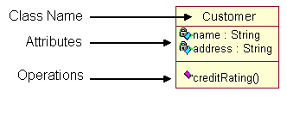
Figure 4.9 – Class Diagram - 1
Class diagrams also display relationships such as containment, inheritance, associations and others. Below is an example of an associative relationship
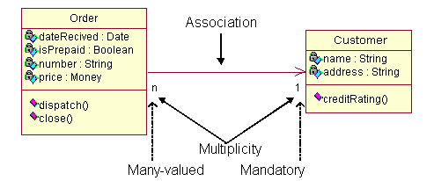
Figure 4.9 – Class Diagram - 2
The association relationship is the most common relationship in a class diagram. The association shows the relationship between instances of classes. For example, the class Order is associated with the class Customer. The multiplicity of the association denotes the number of objects that can participate in the relationship. For example, an Order object can be associated to only one customer, but a customer can be associated to many orders.
Another common relationship in class diagrams is generalization. A generalization is used when two classes are similar, but have some differences. Look at the generalization below:

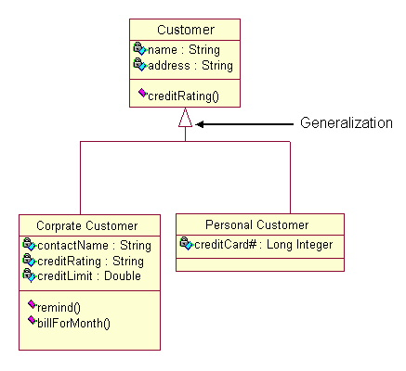
Figure 4.10 – Class Diagram - 3
In this example the classes Corporate Customer and Personal Customer have some similarities such as name and address, but each class has some of its own attributes and operations. The class Customer is a general form of both the Corporate Customer and Personal Customer classes. This allows the designers to just use the Customer class for modules and do not require in-depth representation of each type of customer.
State diagrams are used to describe the behavior of a system. State diagrams describe all of the possible states of an object as events occur. Each diagram usually represents objects of a single class and tracks the different states of its objects through the system.
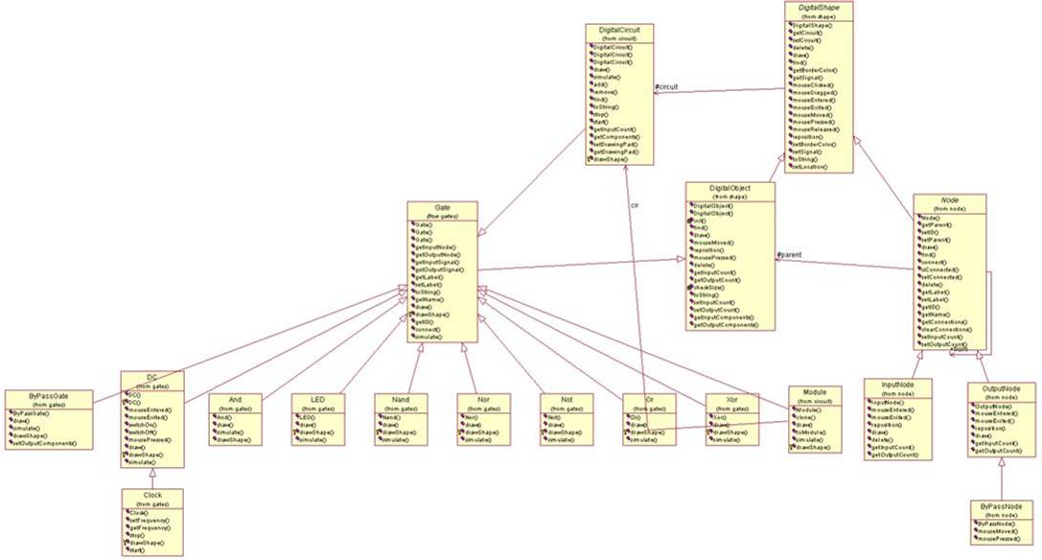
Figure 4.11 - jLogics Class Diagram

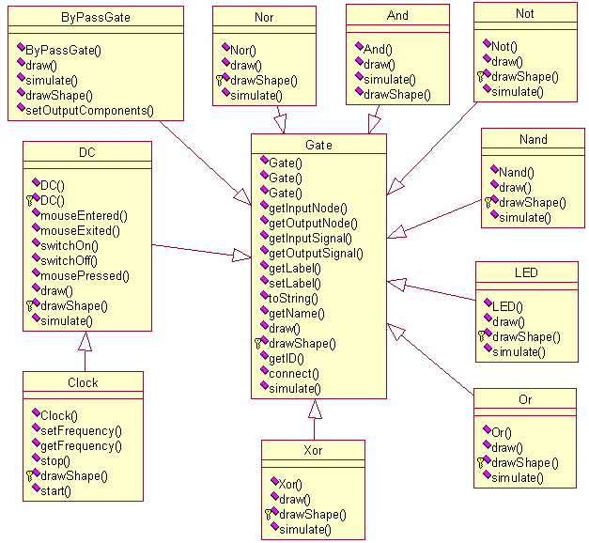
Figure 4.12 - Structure of Gate Class

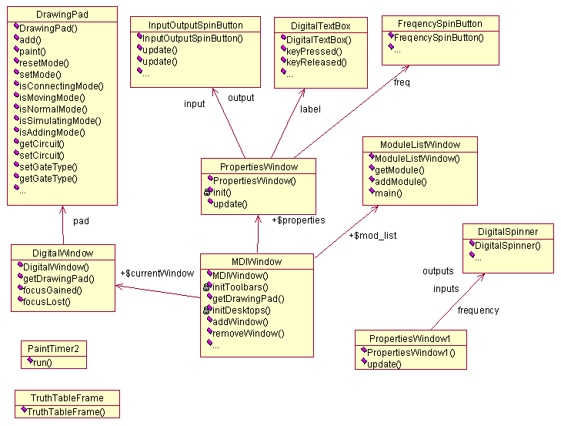
Figure 4.13 - Structure of GUI Classes

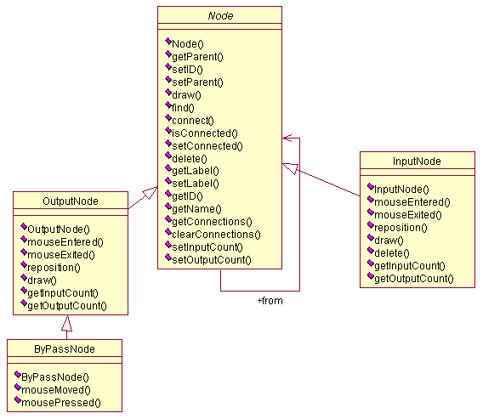
Figure 4.14 - Structure of Node Classes

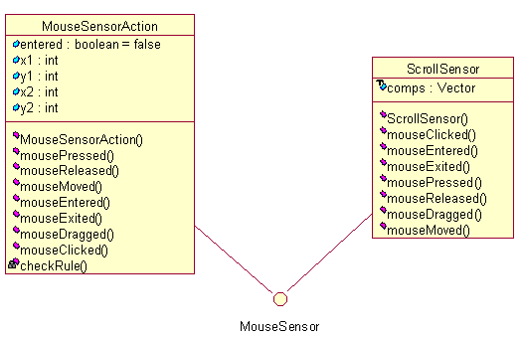

Figure 4.15 - Structure of Mouse Event Classes

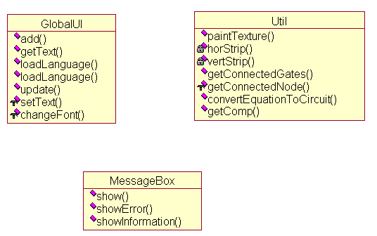
Figure 4.16 - Structure of Utility and Localization Classes

4.6 Component Diagram:
4.6.1 About Component diagrams:
Physical diagrams are used when development of the system is complete. Physical diagrams are used to give descriptions of the physical information about a system.

Many times the deployment and component diagrams are combined into one physical diagram. A combined deployment and component diagram combines the features of both diagrams into one diagram.

The component diagram contains components and dependencies. Components represent the physical packaging of a module of code. The dependencies between the components show how changes made to one component may affect the other components in the system. Dependencies in a component diagram are represented by a dashed line between two or more components. Component diagrams can also show the interfaces used by the components to communicate to each other.

The combined deployment and component diagram below gives a high level physical description of the completed system. The diagram shows two nodes which represent two machines communicating through TCP/IP.
Component2 is dependant on component1, so changes to component 2 could affect component1. The diagram also depicts component3 interfacing with component1. This diagram gives the reader a quick overall view of the entire system.
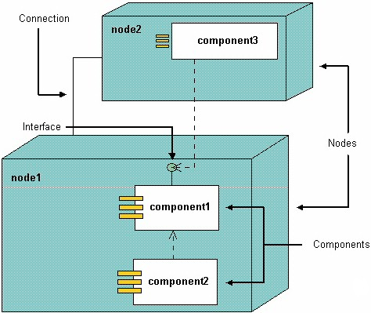
Figure 4.17 – Component Diagram - 1

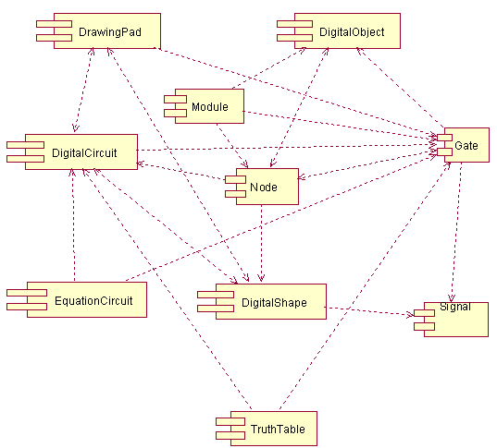
Figure 4.18 – jLogics Component Diagram

The above component diagram, shows the relationship exists between various components. One of the example to be explained in the diagram is that Gate component is being used by various components such as
- DigitalCircuit
- Module
- Truthtable
- EquationCircuit etc.

4.7 Deployment Diagram:

4.7.1 About Deployment diagrams:
A deployment diagram shows processors, devices, and connections. Each model contains a single deployment diagram which shows the connections between its processors and devices, and the allocation of its processes to processors.
Processor Specifications, Device Specifications, and Connection Specifications enable you to display and modify the respective properties. The information in a specification is presented textually; some of this information can also be displayed inside the icons.

You can change properties or relationships by editing the specification or modifying the icon on the diagram. The deployment diagram specifications are automatically updated.
The deployment diagram contains nodes and connections. A node usually represents a piece of hardware in the system. A connection depicts the communication path used by the hardware to communicate and usually indicates a method such as TCP/IP.
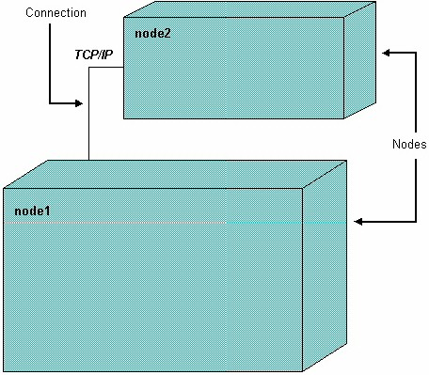

Figure 4.19 – Deployment Diagram - 1
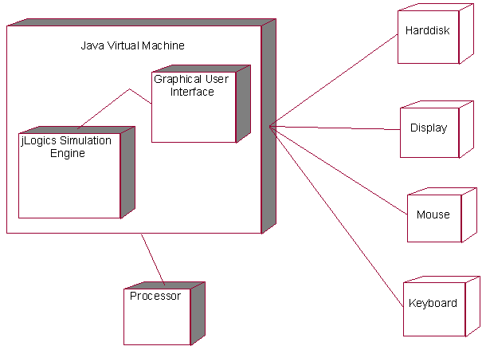

Figure 4.20 – jLogics Deployment Diagram

The deployment diagram shows the various relationship between processes and devices. The Java Virtual Machine ( JVM ), controls the processes such as Graphical User Interface ( GUI ) and jLogics Simulation Engine. The JVM then handles the control between Processor and other devices such as Mouse, Display, Keyboard, Harddisk etc.
5. Implementation

5.1 GUI Design of Jlogics
JLogicsWindow
Property Window
Toolbox
Toolbar
Menus
Drawing Pad

Figure 5.1 - GUI Design of Jlogics

Package: gui
This package contains GUI interface and classes necessary for jLogics

Class: DrawingPad | Extends: JPanel
This class is the drawing pad for the circuit. Components and Gates are placed in this pad, then can be connected, edited etc. This class supports adding of gates, removing of gates, connecting gates, moving of gates etc. This class uses MouseSensor, which is used to sense the mouse action of the user. Also uses Painter class, which is used to draw the components, and connections when ever it is modified.

Class: DigitalWindow | Extends: JInternalFrame
This class is used to design a window , to hold the DrawingPad. This is an Internal frame, because it will be available only inside a MDI Window. Maximize, Minimize, Close operations are made available.

Class: MDIWindow | Extends: JFrame
This is the main window which holds the following windows.
- DigitalWindow
- PropertiesWindow
- ModuleWindow

Class: PropertiesWindow | Extends: JInternalFrame
This class is used to create, properties window that is used for the purpose of viewing and modifying the property of any digital component place in the circuit. Properties such as number of input nodes and output nodes, label for the component, or frequency for the clock component can be set.

Class: ModuleListWindow | Extends: JInternalFrame
This class is used to add / remove modules that are made to be used in the circuit. This class add a new button for each module added in the list. JList class is used for the listing of modules.

Class Name: JlogicsToolbar | Extends: JToolbar
Toolbar has the basic gates such as AND, OR etc. and is used to pick up and draw them in the DrawingPad.

Class Name: JlogicsMenuBar | Extends: JMenuBar
Menu bar, used to for all file actions and miscellaneous action such as circuit to equations, truth table etc.

5.2 Internal Design of the Jlogics

The diagram below is the internal drawing structure of any Gate object in jLogics.
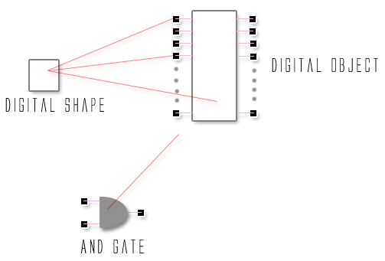

Figure 5.2- Internal Design of the Jlogics

Every component such as Gate, InputNodes, OutputNodes etc are designed as DigitalShape. DigitalShape is a rectangular shaped object. DigitalShape is an abstract class which contains the size, color for the object whether it is a Gate or Node. Then several instances of DigitalShape are then grouped to form a DigitalObject. DigitalObject consist of a Gate Body made by DigitalShape and ‘n’ number of input and ‘m’ number of output nodes. Again the DigitalShape is an Abstract class, since it doesn’t depict any meaning for the gate. It just defines the number of input and output nodes for the gate and doesn’t’ implement any functionality for the gate. From DigitalShape, another class called Gate is derived which contains the Label, Name, Maximum, Minimum Input and output nodes for the gate and the function for gate. The gate contains “simulate” function, which is used to implement the functionality of the particular gate. Gate is again an abstract class, since it don’t have the implementation of all the gate functionality, but it just provides facility to create a New gate Class such as And, Or etc.

Simulate function example
public class And extends Gate {
.............
.............

synchronized public void simulate() {
boolean newSignal = getInputSignal(0).value();
for (int i = 1; i < inputCount; i++) {
newSignal = newSignal && getInputSignal(i).value();
}
this.getOutputSignal(0).value(newSignal);
}
.............
.............
}

5.3 Design of Gate Implementation
Gate
AND
OR
NOT
NAND
NOR
DC
CLOCK
CIRCUIT
MODULE CIRCUIT

Figure 5.3 - Design of Gate Implementation
Package: shape
This package contains classes necessary for drawing and displaying the shape of the gate and other objects used in the software.

Class: DigitalShape | Extends: Rectangle | Implements: MouseSensor
This class describes the rectangular shape of any component that is being used as gate, node etc. This contains method “draw()” to draw and display the object. This class is Abstract class, hence cannot create object for this. This class contains the implementation of MouseEvents such as, mouse click, mouse move, mouse pressed events. These methods are made available from MouseSensor class.

Class: DigitalObject | Extends: DigitalShape
This class is for specification of any digital object with nodes and shape. The main difference between DigitalShape and DigitalObject is that, DigitalObject contains the details of the Nodes that an object is going to possess. Node is also designed using DigitalShape class. This is also an abstract class

Package: gates
This package contains classes necessary for logic gates

Class: Gate | Extends: DigitalObject
This class defines the properties about any logic gate that is going to be used in the simulator. Since the Gate class is being inherited from DigitalShape and DigitalObject, it can Draw and posses nodes. This gate contains the description of a logic gate such as number of input nodes, number of output nodes, label for the gate, maximum and minimum number of input and output nodes for the gates. It also has function for simulating the gate. This is abstract function and each logical gate should override this and implement its own working function.

Class: And |  | Extends: Gate
This class defines the operation of AND logic. It overrides the simulate function and implements the working behavior of AND logic. It receives all the input from the Input Nodes then perform and operation and then finally sets the output to the Output Node.
Logic: | If any of the input is FALSE, then the output is FALSE, else the output is TRUE

Class: Or |  | Extends: Gate
This class defines the operation of OR logic. It overrides the simulate function and implements the working behavior of OR logic. It receives all the input from the Input Nodes then performs the operation and then finally sets the output to the Output Node.
Logic: | If both of the input are FALSE, then the output is FALSE, else the output is TRUE

Class: Not |  | Extends: Gate
This class defines the operation of NOT logic. It overrides the simulate function and implements the working behavior of NOT logic. It receives all the input from the Input Nodes then performs the operation and then finally sets the output to the Output Node. This node has only one input node and one output node.
Logic: | If input is TRUE, Output is FALSE, vice versa

Class: Nand |  | Extends: Gate
This class defines the operation of NAND logic. It overrides the simulate function and implements the working behavior of NAND logic. It receives all the input from the Input Nodes then performs the operation and then finally sets the output to the Output Node. This node has only one input node and one output node.
Logic: | If Both the input is TRUE, then Output is FALSE, Else Output is TRUE

Class: Nor |  | Extends: Gate
This class defines the operation of NOR logic. It overrides the simulate function and implements the working behavior of NOR logic. It receives all the input from the Input Nodes then performs the operation and then finally sets the output to the Output Node. This node has only one input node and one output node.
Logic: | If Both the input is FALSE, then Output is TRUE, Else Output is FALSE

Class: Xor |  | Extends: Gate
This class defines the operation of XOR logic. It overrides the simulate function and implements the working behavior of XOR logic. It receives all the input from the Input Nodes then performs the operation and then finally sets the output to the Output Node. This node has only one input node and one output node.
Logic: | If both the input are not same then Output is TRUE, else FALSE

Class: DC | Extends: Gate
This class defines the operation of DC Supply for the gates. It overrides the simulate function and implements the working behavior of Switch On and Off. If mouse is clicked on the OFF state, then the component turns ON the supply, else if clicked in the On State, then the component turns OFF the supply.

Class: LED | Extends: Gate
This class is used to receive any signal and display as an output. It has only one input node and no output nodes. It overrides the simulate function, just to receive the signal and display it.

Package: nodes
This package contains classes necessary for logic gates

Class: Node | Extends: DigitalObject
This class defines the functionality of Node for any logic gate. This class , defines the size of the node, position of the node from the gate, and transfer of signals etc. This is abstract class, as for InputNode and OutputNode, different classes has been designed

Class: InputNode | Extends: Node
This class used to define the functionality of any Input Node for any logic gate. Input node, receives the signal from the output node of the gate to which the input node is connected and passes it to its gate for the operation. It always lies left to any gate.

Class: OutputNode | Extends: Node
This class used to define the functionality of any Output Node for any logic gate. Output node, has the signal ready to supply for the other connected input nodes . It always lies right to any gate.

5.4 Types of gates
Table 5.1
Component | Symbol | Function
DC | 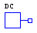 | Gives DC supply to the circuit.
Clock | 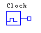 | Gives clock to the circuit.
And | 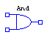 | It performs the logical multiplication.It can have two or more inputs for which it will produce a single output.
Or | 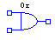 | It performs the logical addition.It can have two or more inputs for which it will produce a single output.
Not | 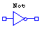 | This performs the inversion or complementation.This inverts one logical level to its opposite level.In terms of bits it will convert binary 1 to binary 0 and viseverse.
Nand | 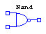 | It is a contraction of NOT-AND that implies an AND function with complemented ouput
Nor | 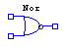 | It is a contraction of NOT-OR that implies an OR function with complemented output.
Xor | 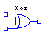 | Functions as the logic Xor gate., if two inputs are same, then the output is FALSE
Led | 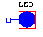 | To view the output, acts as LED
Simulate |  | Used to simulate the circuit.
5.5 Properties of DigitalObject:
- A label for it’s name
- N inputs
- M outputs
- A list to store the other components connected to the input
- A list to store the other components connected to the output
- A method to simulate a single Component
- All other classes, which want the property of the gate, will extend its property.

5.6 Properties of the Circuit Class:
Circuit is another important class where the role of circuit comes. Each drawing pad consists of a circuit layout that is of Circuit class. A circuit class has the following functions.
- List to store the objects drawn in the circuit.
- Method to simulate all the objects in the circuit.
- Methods to handle CLOCK objects.
- Add and delete objects in the circuit.
- Method to convert the while circuit into a small module.
- Method to reset all the objects placed in the circuit.
- After drawing a circuit the circuit can be save, the contents of the circuit file is the Content of Circuit class.

5.7 Algorithms Framed

5.7.1 Simulation Algorithm
for every gate D in the circuit C
Inputs := D.Inputs
for every input I in Inputs
Calculate the output value(s) using the function assigned for the gate.
end
Set the output values to the inputs connected to the output node of the next component
Select Next Component which connected to the output of D as D’
D := D’
end
Table 5.2 - Simulation Algorithm

Explanation:

The simulation algorithm is the main algorithm that simulates the gates and components according to the given input. The simulation algorithm works as follows. The algorithm takes each and every gate that is being available in the circuit. Then it fetches gate one by one and takes the inputs of every gate. The gate function is applied on the input of the current gate and the output of the function is passed to the output node of the current node. The output node, supplies the input for the next gate connected the current gate and the process continues until it process the entire gate available in the circuit.

5.7.2 Module Conversion algorithm
for every gate G in the circuit C
if G is DC then
ByPassGate BG = ByPassGate(G)
BG.Outputs = G.Outputs
connect(BG,input(i))
else if G is LED then
ByPassGate BG = ByPassGate(G)
BG.Inputs = LED.Inputs
connect(BG,output(j))
end
end
Table 5.3 - Module Conversion

Explanation:

This algorithm is bit complex and is implemented with lot of care. For converting a IC module, first the input and output for the IC should be determined. Those are done through the available DC and LED gates. Number of DC Components in the circuit designate the Input Nodes of the Module and Number of LED designates the Output for the Module.
First, the input and output nodes are created based on the above condition. Next, if the Gate G is DC Gate, convert G into ByPassGate and add it to the circuit. Make connection of ‘i’ th input node to the input of by pass and transfer the outputs of G to ByPassGate. Same thing but a slight different way for output nodes. If the Gate G is LED Gate, convert G into ByPassGate and add it to the circuit. Make connection of ‘j’ th output node to the input of by pass and transfer the inputs of G to ByPassGate.

5.7.3 Gate Connection Algorithm
Two gates can be connected if and only if
Source := Type OutputNode class
Target := Type InputNode class
Else
A error message is displayed inorder to alert the user.
End
Table 5.4 - Gate Connection Algorithm

Explanation:
The algorithm states that to make any connection between two gates, the output should be connected be connected to the input node and the reverse is not possible.Else error message will be displayed.

5.7.4 Equation Parsing algorithm
Parse the Boolean equation into tokens using the rules as given below in BNF form
<expression> ::= <expression> + <expression> |
<expression> * <expression> |
<expression> ^ <expression> |
<expression> @ <expression> |
- <expression> |
<expression> ‘|’ <expression> |
( <expression> ) |
<id>
<id> ::= (‘a’..’z’ | ‘A’..’Z’) (‘a’..’z’ | ‘A’..’Z’ | ‘0’..’9’)*
Table 5.4 - Equation Parsing

Explanation:
The above is the BNF ( Bacus Naur Form ) of the equation that is being recognized. The Equation Parser for the above grammar is being constructed. The parser starts with <expression> rule and moves recursively down for scanning entire given expression.

5.7.5 Equation to Circuit Algorithm
Save all the token in a list called Tokens
Initialize Stack S
for each token T in the Tokens
If T = Variable //i.e A,B,C etc
G:=Convert T in respective gate
else if T = Gate
If T = BinaryGateSymbol //i.e +, *
G:=Pop out two gates that have been pushed last and make connection between them,
else T = UnaryGateSymbol //i.e ‘-’
G:=Pop out one gates that have been pushed last and make connection between them
end
end
Push G into S
end
Table 5.5 - Equation to Circuit Algorithm
Explanation :
This algorithm gets a postifx expression as input. If the expression contains only one variable , it takes it to be a DC source. Depending on the operators gates are created and the previous gate(s) in the stack is popped out and the corresponding connections are made. Finally after connecting all the gates, a LED gate is created for the output and connected to the gate available in the stack.

5.7.6 Truth table generation algorithm
nbits ::= No.of DC Source in the circuit
nvalue ::= 2 ^ nbits

For I = 1 to nvalue
InBits := getBits( I )
Apply the InBits to each of the DC component, i.e set DC source to ON if bit is 1, else set to OFF state.
Simulate the Circuit once.
If the LED is ON then
add a bit 1 OutBit
else if OFF then
add a bit 0 to OutBit
End
Put all the bits in a table to view
End

Algorithm:
getBits ( Integer I )
bits := Array of Integers
Start
for j = 1 to nbits
bits[j] = (I & 1 << j) >> j
end
return bits
End
Table 5.6 - Truthtable generation
Explanation:
To generate the truth table for the given circuit, the first operation is the identification of number of input sources in the given circuit. It represents the no.of input bits for the table and the no.of LED’s designate the no.of output bits. Then getBits( I ), is used to get the ‘i’ th bit of the number, it may be ZERO ( 0 ) or ONE ( 1 ). The ‘i’ the bit, is fed as input to the ‘i’ th DC source. Then after feeding all the inputs bits, the circuit is simulated once and then the Ouput from LED’s are colleted.

5.8 Localization
Localization is the determination of the locality (position) of an object. localization refers to the adaptation of language, content and design to reflect local cultural sensitivities. Often, localization is the adoption of an object to a locality. An example is in software localization, where the messages which a program presents to a user need to be translated into various languages. The word "Localization" is occasionally abbreviated as "l10n" (the number ten between the letters l and n) because there are ten letters between its first and the last letters.

5.9 Necessesity for localization in jLogics.

Since it is designed as a tool for educational purpose, the main motive is to reach each and every student or learner anywhere, in spite of the location. The learner can always understand better if he learns in his / her local language. jLogics, provides way to implement the Localization (l10n) and even Internationalization(I18n) in the software. Currently, Tamil language support is being implemented in jLogics. This can also be extended to languages like Hindi, Kannada etc. Localization is necessarily complex part in the software, because the reason as follows.
- It is certainly true that localization involves translation (e.g. of manuals and other documentations, screens, help texts, and error messages).
- Equally, product names may have to be changed to avoid unfortunate associations in the target language.
- On the software programming side the following things should be ensure
  - screen dialog boxes
  - field lengths may have to be altered
  - date, time and currency formats changed
  - delimiters for figures replaced
  - and icons and colors adapted
- more extensive reprogramming may be required to ensure that localized text and numerals are displayed correctly on the target platforms.

5.10 Why Localization?
LISA(Localization Industry Standards Association) estimates that the localization sector is currently generating sales of between USD 3 billion and USD 15 billion a year. This brings results: the 20 largest IT companies now annually leverage a localization spend of around USD 1.5 billion to generate sales in excess of USD 50 billion. Also by the survey that non English speaking users increases exponentially and information reaches faster and gets covered by more people through localization and internationalization techniques.

Tamil glyphs in XML file :
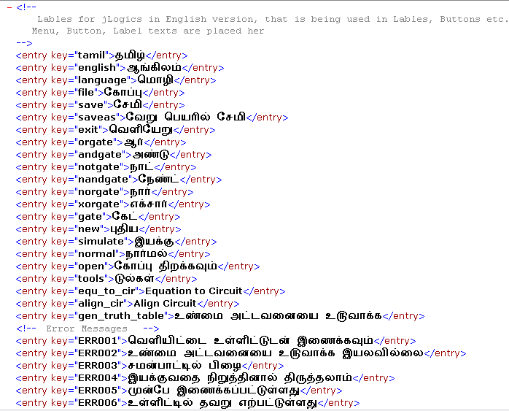
Figure 5.4- Tamil glyphs in XML file

The above picture is the Tamil words placed in the XML File for the display of labels in JLabel, JButtons , Message Boxes etc.

English glyphs in XML file :
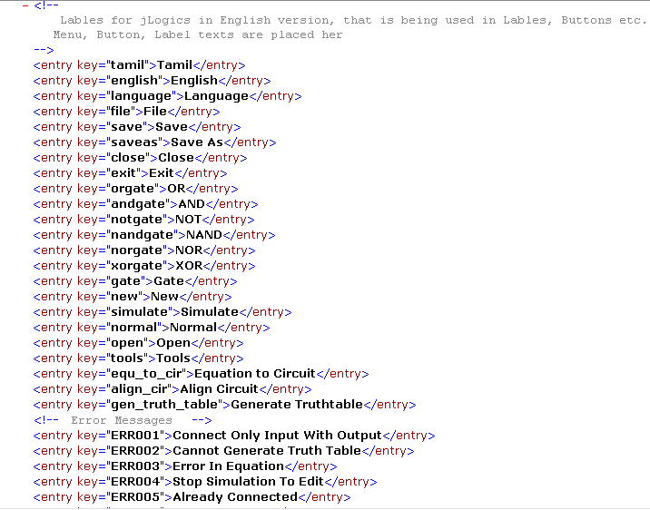
Figure 5.5- English glyphs in XML file

The above picture is the english words placed in the XML File for the display of labels in JLabel, JButtons , Message Boxes etc.

5.11 Equation Minimization

The equation minimization or reduction is one of the features available in this software. The reductions are written as rules in Prolog. Since prolog can be used for easy text matching, it is also used in this software. The equation reduction is still under construction. For now reduction of simple equations alone have been handled. To have a look at the rules, open the mini.pl file and the rules can be added and modified. Some rules for example are,

logic( A + 0 , A ). This rule says that A + 0 = A.
logic( A + A , A ). This rule says that A + A = A.
logic( A * A , A ). This rule says that A * A = A.

To interface the prolog with java, we use gnuprolog.jar file placed in /lib directory. It is distributed under GPL license. So it provides the interface. We have created a PrologEngine class, which makes the interface by initializing the prolog engine, then reading the file , then executing the goal and also error handling.

5.12 Mouse Operations

Mouse operations are one of the important feature implemented in jLogics, as it is GUI oridented application. Two class are provided by Java for the mouse operations such as
MouseListener
MouseMotionListener

MouseListener class provides the following functions
Void mouseClicked(MouseEvent e)
Invoked when the mouse button has been clicked (pressed and released) on a component.
Void mouseEntered(MouseEvent e)
Invoked when the mouse enters a component.
Void mouseExited(MouseEvent e)
Invoked when the mouse exits a component.
Void mousePressed(MouseEvent e)
Invoked when a mouse button has been pressed on a component.
Void mouseReleased(MouseEvent e)
Invoked when a mouse button has been released on a component.
MouseMotionListener provides the following functions
Void mouseDragged(MouseEvent e)
Invoked when a mouse button is pressed on a component and then dragged.
Void mouseMoved(MouseEvent e)
Invoked when the mouse cursor has been moved onto a component but no buttons have been pushed.

The mouse operations differ for components to components. The mouse clicks with various keys combinations.
SHIFT + Mouse Click on any component | Moves the object to the direction of the mouse.
CONTRL + Mouse Click on any component | Delete the Object
CONTROL + Mouse Click on OutputNode | Delete the outgoing connections
Click on Output Node | Ready Make connection for gates through Output and Input Nodes
Table 5.8 - Mouse Button Operations

5.13 Keyboard Operations

Java provides classes for the keyboard interface. The KeyListener class provides the following functions
Void keyPressed(KeyEvent e)
Invoked when a key has been pressed.
Void keyReleased(KeyEvent e)
Invoked when a key has been released.
void keyTyped(KeyEvent e)
Invoked when a key has been typed.

- ESCAPE KEY - Sets the drawing pad to normal mode, if it is under ADD, DELETE or MOVING Mode

5.14 Rendering

All the graphical objects such as gates, circuits, modules, windows, menu bars, toolbars etc as created using the inbuilt java classes which are provided by default in java itself. Packages used are
java.awt.*
java.awt.events.*
java.awt.geom.*
javax.swing.*
javax.swing.tables.*

Graphical rendering of gates and other visual objects are done using Painter thread, which paints the drawing pad, constantly whenever there is a mouse movement, key press, mouse action etc. The Painter class consist of AutoPainter, which paints / renders the display for a given duration of time, irrespective of any of actions.

6.Testing

6.1 Test cases

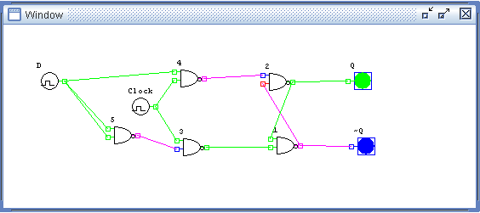
Figure 6.1 - D-Flip Flop

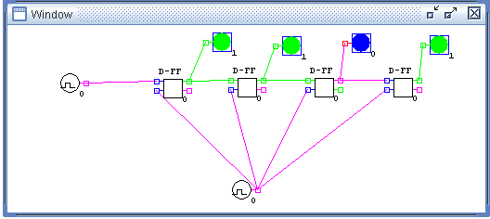
Figure 6.2 - Shift Register – 4 Bits , Showing 1101

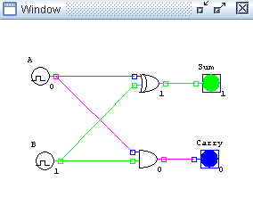
Figure 6.3 - Half Adder

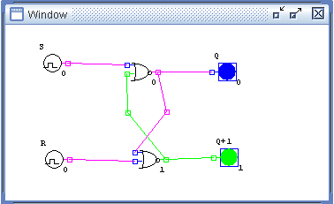
Figure 6.4 - RS-Flip Flop

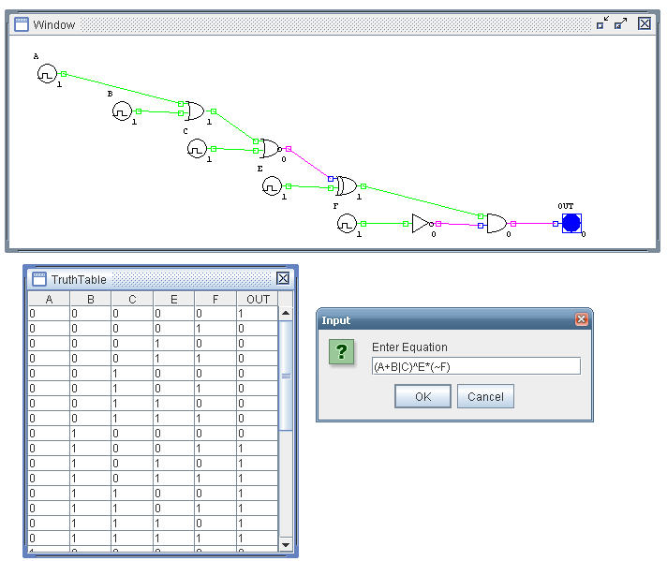
Figure 6.5 - Circuit (A+B|C)^E*(~F) – (A OR B NOR C) XOR E AND (NOT F)

7. Snap shots

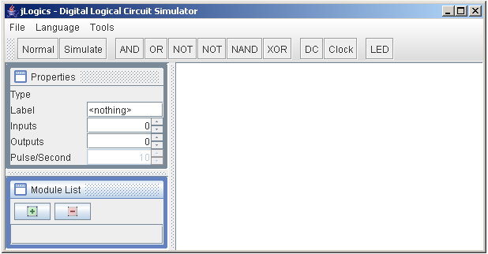 Figure 7.1 - Snapshot of English Version

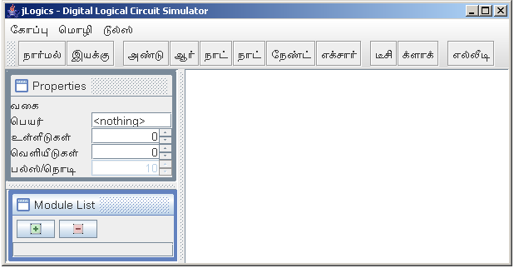
Figure 7.2 - Snapshot of Tamil Version

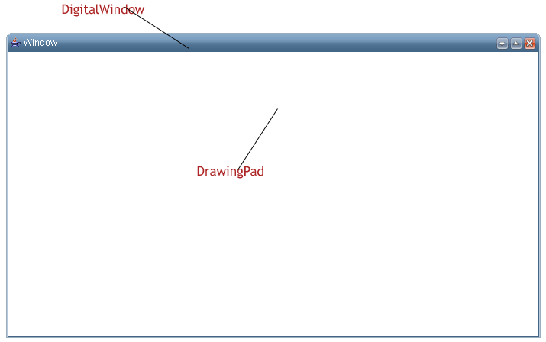
Figure 7.3 - Snapshot of Drawingpad

Figure 7.4 - Snapshot of Toolbar

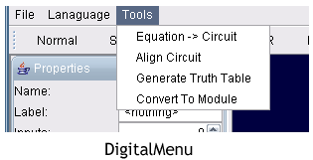
Figure 7.5 - Snapshot of Menubar

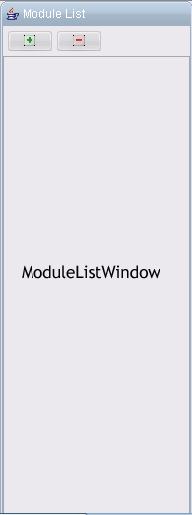
Figure 7.6 - Snapshot of Module List window

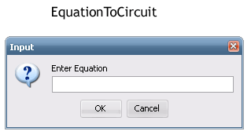
Figure 7.7 - Snapshot of Equation to Circuit Window

8. Sample Code

GlobalUI.java
package util;
import java.awt.Component;
import java.awt.Font;
import java.io.FileInputStream;
import java.io.IOException;
import java.util.Enumeration;
import java.util.Properties;
import java.util.Vector;
import javax.swing.AbstractButton;
import javax.swing.JComponent;
import javax.swing.JLabel;
import javax.swing.SwingUtilities;
import javax.swing.UIManager;
import javax.swing.plaf.FontUIResource;
import javax.swing.text.JTextComponent;
public class GlobalUI {
public static final String ENGLISH = "english.xml";
public static final String TAMIL = "tamil.xml";
public static String FONT_NAME = "Arial Unicode MS";
private static int fontSize = 12;
static Vector labelList, controls;
static Properties p;
static {
labelList = new Vector();
controls = new Vector();
p = new Properties();
loadLanguage(ENGLISH);
}
public static void add(JComponent c, String label) {
controls.add(c);
labelList.add(label);
}
public static String getText(String key) {
return p.getProperty(key);
}
public static void loadLanguage(String lang) {
loadLanguage(lang, null);
}
public static void loadLanguage(String lang, Component f) {
/*
* load the properties file according to the langauge
*/
try {
FileInputStream fin = new FileInputStream(lang);
p.loadFromXML(fin);
} catch (IOException e) {
e.printStackTrace();
}
/*
* change the font according to the language
*/
FONT_NAME = p.getProperty("FONT");
fontSize = Integer.parseInt(p.getProperty("SIZE"));
if (lang == ENGLISH) {
changeFont(FONT_NAME, fontSize);
} else if (lang == TAMIL) {
changeFont(FONT_NAME, fontSize);
}
if (f != null)
SwingUtilities.updateComponentTreeUI(f);
}
public static void update() {
int len = controls.size();
for (int i = 0; i < len; i++) {
JComponent c = (JComponent) controls.get(i);
String text = labelList.get(i).toString();
setText(c, text);
}
}
static void setText(JComponent cp, String name) {
if (cp instanceof AbstractButton) {
((AbstractButton) cp).setText(p.getProperty(name));
} else if (cp instanceof JLabel) {
((JLabel) cp).setText(p.getProperty(name));
} else if (cp instanceof JTextComponent) {
((JTextComponent) cp).setText(p.getProperty(name));
}
}
static void changeFont(String FONT_NAME, int fontSize) {
Enumeration e = UIManager.getDefaults().keys();
FontUIResource f = new FontUIResource(FONT_NAME, Font.PLAIN, fontSize);
while (e.hasMoreElements()) {
Object key = e.nextElement();
Object value = UIManager.get(key);
if (value instanceof FontUIResource) {
UIManager.put(key, f);
}
}
}
}
MessageBox.java
package util;
import java.awt.Font;
import javax.swing.JFrame;
import javax.swing.JLabel;
import javax.swing.JOptionPane;
public class MessageBox extends JFrame {
/*
* type=1 INFORMATION type=0 ERROR
*
*/
public static final int ERROR = JOptionPane.ERROR_MESSAGE;
public static final int INFO = JOptionPane.INFORMATION_MESSAGE;
public static final int YES = JOptionPane.YES_OPTION;
public static final int NO = JOptionPane.NO_OPTION;
public static final int CANCEL = JOptionPane.CANCEL_OPTION;
public static void show(String title, String message, int type) {
String mesg = GlobalUI.getText(message);
if (mesg == null || mesg == "")
mesg = message;
JLabel msg = new JLabel(mesg);
msg.setFont(new Font(GlobalUI.FONT_NAME, Font.PLAIN, 12));
JOptionPane.showMessageDialog(null, msg, title, type);
}
public static void showError(String message) {
show("Error", message, ERROR);
}
public static void showInformation(String message) {
show("Information!", message, INFO);
}
public static int ask(String title, String message) {
return JOptionPane.showConfirmDialog(null, message, title,
JOptionPane.YES_NO_OPTION, INFO);
}
}

EquationCircuit.java
package parser;
import gates.And;
import gates.DC;
import gates.Gate;
import gates.LED;
import gates.Nand;
import gates.Nor;
import gates.Not;
import gates.Or;
import gates.Xor;
import gui.MDIWindow;
import java.util.ArrayList;
import java.util.HashMap;
import java.util.Iterator;
import java.util.LinkedList;
import java.util.Stack;
import java.util.Vector;
import util.Util;
import circuit.DigitalCircuit;
public class EquationCircuit {
PostfixExpression expr;
HashMap store;
DigitalCircuit cir;
Stack stk;
LinkedList list;
static int x = 30, y = 30, INC_X = 80, INC_Y = 40;
public EquationCircuit() {
expr = new PostfixExpression();
store = new HashMap();
cir = new DigitalCircuit();
stk = new Stack();
}
public DigitalCircuit convert(String s) {
expr.toPostFix(s);
list = expr.getTokens();
Gate g = null;
cir.setDrawingPad(MDIWindow.getDrawingPad());
for (int i = 0; i < list.size(); i++) {
String x = (String) list.get(i);
if ("+*|^@~".indexOf(x) > -1) { //some operators
Gate cir_b = (Gate) stk.pop();
if (x.equalsIgnoreCase("~")) { //single output gate
g = new Not();
cir_b.connect(0, g, 0);
} else { //double output gate
Gate cir_a = (Gate) stk.pop();
if (x.equalsIgnoreCase("+")) {
g = new Or();
cir_a.connect(0, g, 0); //connect a to Or gate 0th node
cir_b.connect(0, g, 1); //connect a to Or gate 1st node
} else if (x.equalsIgnoreCase("*")) {
g = new And();
cir_a.connect(0, g, 0); //connect a to Or gate 0th node
cir_b.connect(0, g, 1); //connect a to Or gate 1st node
} else if (x.equalsIgnoreCase("^")) {
g = new Xor();
cir_a.connect(0, g, 0); //connect a to Or gate 0th node
cir_b.connect(0, g, 1); //connect a to Or gate 1st node
} else if (x.equalsIgnoreCase("|")) {
g = new Nor();
cir_a.connect(0, g, 0); //connect a to Or gate 0th node
cir_b.connect(0, g, 1); //connect a to Or gate 1st node
} else if (x.equalsIgnoreCase("@")) {
g = new Nand();
cir_a.connect(0, g, 0); //connect a to Or gate 0th node
cir_b.connect(0, g, 1); //connect a to Or gate 1st node
}
}
cir.add(g);
stk.push(g);
} else { //create source from variables
DC d;
if (!store.containsKey(x)) { //if already the variable is not
// available, create
d = new DC();
d.setLabel(x);
store.put(x, d);
} else {
d = (DC) store.get(x);
}
cir.add(d);
stk.push(d); //push into stack
}
}
LED out = new LED();
out.setLabel("OUT");
g = (Gate) stk.pop();
g.connect(0, out, 0);
cir.add(out);
stk.clear();
return cir;
}
public static void align(DigitalCircuit cir) {
Vector in = cir.getComponents();
for (Iterator i = in.iterator(); i.hasNext();) {
Gate g = (Gate) i.next();
if (g instanceof DC) {
DC dc = (DC) g;
dc.setLocation(x, y);
align(dc, x);
y += INC_Y;
x += INC_X;
}
}
x = y = 50;
}
public static void align(Gate gate, int x1) {
ArrayList gates = Util.getConnectedGates(gate);
for (Iterator j = gates.iterator(); j.hasNext();) {
Gate g = (Gate) j.next();
g.setLocation(x1 + INC_X, y);
align(g, x1 + INC_X);
}
}
}

PostfixExpression.java
package parser;
import java.util.LinkedList;
import java.util.Stack;
import java.util.StringTokenizer;
import java.util.Vector;
public class PostfixExpression {
public final static char SYM_AND = '*';
public final static char SYM_NAND = '@';
public final static char SYM_NOR = '|';
public final static char SYM_NOT = '~';
public final static char SYM_OR = '+';
public final static char SYM_XOR = '^';
/** ------------variables declaration-------------* */
private String delim = "+*~()^@|";
private String infix, postfix;
public int NOT_VALID_SYMBOL = -1;
private StringTokenizer tokens;
private LinkedList toks;
private Vector varList;
public PostfixExpression() {
this.postfix = null;
}
private void addVariable(String s) {
if (!varList.contains(s) && isVariable(s))
varList.add(s);
}
public String getExpression() {
return infix;
}
private int getPrecedence(String s) {
char c = s.charAt(0);
switch (c) {
case '(' :
return 0;
case '+' :
case '*' :
case '^' :
case '|' :
case '@' :
return 1;
case '~' :
return 2;
default :
return NOT_VALID_SYMBOL;
}
}
public LinkedList getTokens() {
return toks;
}
public Vector getVariables() {
return varList;
}
private void intoPostFix() {
String cur_oper, old_oper;
Stack opr = new Stack();
String tempStr = removeSpace(infix);
varList = new Vector();
toks = new LinkedList();
tokens = new StringTokenizer(tempStr, delim, true);
while (tokens.hasMoreTokens()) {
String s = tokens.nextToken();
addVariable(s);
if (isVariable(s)) {
toks.add(s);
} else {
cur_oper = s;
if (cur_oper.equalsIgnoreCase("("))
opr.push(cur_oper);
else if (cur_oper.equalsIgnoreCase(")")) {
boolean match = false;
while (!opr.isEmpty()
&& (old_oper = opr.pop().toString()) != null) {
if (old_oper.equals("(")) {
match = true;
break;
}
toks.add(old_oper);
}
if (!match)
throw new IllegalArgumentException(
"Error In Paranthesis");
} else {
while (!opr.isEmpty()
&& getPrecedence(opr.peek().toString()) >= getPrecedence(cur_oper)) {
old_oper = opr.pop().toString();
toks.add(old_oper);
}
opr.push(cur_oper);
}
}
}
while (!opr.isEmpty()) {
old_oper = opr.pop().toString();
if (old_oper.equals("(") || old_oper.equals(")"))
throw new IllegalArgumentException("Error In Paranthesis");
toks.add(old_oper);
}
postfix = toks.toString();
}
private boolean isAlphaNumeric(String v) {
boolean flag = false;
for (int i = 0; i < v.length(); i++) {
flag = Character.isLetterOrDigit(v.charAt(i))
|| Character.isDefined(v.charAt(i));
if (false == flag)
return flag;
}
return flag;
}
public boolean isVariable(String v) {
if (Character.isLetter(v.charAt(0)) && isAlphaNumeric(v))
return true;
return false;
}
private String removeSpace(String s) {
StringBuffer temp = new StringBuffer();
int i = 0;
for (; i < s.length(); i++) {
if (s.charAt(i) == ' ')
continue;
temp.append(s.charAt(i));
}
return temp.toString();
}
public String toPostFix(String expression) {
this.infix = expression;
intoPostFix();
return postfix;
}
}

TruthTable.java
package truthtable;
import gates.DC;
import gates.Gate;
import gates.LED;
import java.util.ArrayList;
import java.util.Iterator;
import java.util.Vector;
import circuit.DigitalCircuit;
public class TruthTable {
Vector head;
public Vector getHeader() {
return head;
}
public Vector generateTable(DigitalCircuit cir) {
Vector data = new Vector();
head = new Vector();
ArrayList dc = cir.getInputComponents();
ArrayList led = cir.getOutputComponents();
int input_bits = dc.size();
int total_inputs = (int) Math.pow(2, input_bits);
int total_outputs = led.size();
for (int i = 0; i < total_inputs; i++) {
Vector row = new Vector();
String val = "";
//set the input bits
for (int k = input_bits - 1; k >= 0; k--) {
int bit = getBit(i, k);
DC d = (DC) dc.get(k);
if (bit == 1) {
d.switchOn();
} else {
d.switchOff();
}
row.add(bit + "");
}
cir.simulate(); //simulate the circuit after setting all inputs
//get the output bits
for (int k = 0; k < total_outputs; k++) {
LED l = (LED) led.get(k);
int bit = l.getSignal().isOn() ? 1 : 0;
row.add(bit + "");
}
data.add(row);
}
for (Iterator i = dc.iterator(); i.hasNext();) {
Gate d = (Gate) i.next();
head.add(d.getLabel());
}
for (Iterator i = led.iterator(); i.hasNext();) {
Gate d = (Gate) i.next();
head.add(d.getLabel());
}
return data;
}
int getBit(int num, int pos) {
return (num & (1 << pos)) >> pos;
}
}

And.java
package gates;
import java.awt.Graphics2D;
public class And extends Gate {
public And() {
super("AND", AND);
}
synchronized public void draw(Graphics2D g) {
simulate();
super.draw(g);
}
synchronized public void simulate() {
boolean newSignal = getInputSignal(0).value();
for (int i = 1; i < inputCount; i++) {
newSignal = newSignal && getInputSignal(i).value();
}
this.getOutputSignal(0).value(newSignal);
}
public void drawShape(Graphics2D g) {
g.drawLine(x, y, x, y + height);
g.drawArc(x - width, y, 2 * width, height, 90, -180);
}
}

Gate.java
package gates;
import gui.PropertiesWindow;
import java.awt.Color;
import java.awt.Font;
import java.awt.Graphics2D;
import node.Node;
import properties.Properties;
import shape.DigitalObject;
import signal.Signal;
public abstract class Gate extends DigitalObject implements Properties {
public static final long AND = 1;
public static final long OR = 2;
public static final long NAND = 3;
public static final long NOR = 4;
public static final long XOR = 5;
public static final long NOT = 6;
public static final long DC = 7;
public static final long CLOCK = 8;
public static final long LED = 9;
public static final long NODE = 10;
public static final long FLIP1 = 11;
public static final long BYPASS = 12;
public static final long TOGGLE = 13;
public int MAX_INPUTS, MAX_OUTPUTS, MIN_INPUTS, MIN_OUTPUTS;
String label;
Font fnt;
final String name;
public final long id;
/**
* @param p
* @param inputCount
* @param outputCount
*/
public Gate(String name, long id) {
/*
* Minimum 2 Inputs, 1 Output Maximum 16 Inputs, 1 Output
*/
this(name, 2, 1, 16, 1, id);
}
public Gate(String name, int inputs, int outputs, long id) {
/*
* Minimum n Inputs, n Output Maximum 16 Inputs, 16 Output
*/
this(name, inputs, outputs, 16, 16, id);
}
public Gate(String name, int minInputs, int minOutputs, int maxInputs,
int maxOutputs, long id) {
super(minInputs, minOutputs);
this.MIN_INPUTS = minInputs;
this.MIN_OUTPUTS = minOutputs;
this.MAX_INPUTS = maxInputs;
this.MAX_OUTPUTS = maxOutputs;
this.name = name;
this.id = id;
fnt = new Font("Courier", Font.PLAIN, 10);
}
public Node getInputNode(int node) {
return (Node) inputs.get(node);
}
public Node getOutputNode(int node) {
return (Node) outputs.get(node);
}
public Signal getInputSignal(int node) {
if (inputs != null && inputs.size() > 0) {
Node n = (Node) inputs.get(node);
return n.getSignal();
}
return null;
}
public Signal getOutputSignal(int node) {
if (outputs != null && outputs.size() > 0) {
Node n = (Node) outputs.get(node);
return n.getSignal();
}
return null;
}
/**
* @return Label of the Gate
*/
public String getLabel() {
return label;
}
/**
* Sets a Label to the Gate
*
* @param string
*/
public void setLabel(String string) {
label = string;
}
public String toString() {
return "<" + getName() + ">";
}
/**
* @return Type of the Gate
*/
public String getName() {
return name;
}
synchronized public void draw(Graphics2D g) {
super.draw(g);
g.setColor(Color.BLACK);
g.setFont(fnt);
if ( this.getLabel() != null)
g.drawString(this.getLabel(), x - 5, y - 5);
if(PropertiesWindow.isShowBit()) {
g.drawString(this.getSignal().getBit(), x + width, y + height + 5);
}
drawShape(g);
}
protected abstract void drawShape(Graphics2D g);
public long getID() {
return id;
}
public void connect(int outNodePos, Gate dest, int inNodePos) {
/*
* connect this nodes output to the input of dest node , to the destNode
* location
*/
Node n1 = getOutputNode(outNodePos);
Node n2 = dest.getInputNode(inNodePos);
n1.connect(n2);
}
public abstract void simulate();
}

DC.java
package gates;
import java.awt.Color;
import java.awt.Graphics2D;
import java.awt.event.MouseEvent;
import node.Node;
public class DC extends Gate {
public DC() {
this("DC");
}
public DC(String name) {
super(name, 0, 1, 0, 1, DC);
setBorderColor(Color.BLUE);
}
public void mouseEntered(MouseEvent e) {
if (pad.isSimulatingMode())
pad.setCursor(HAND_CURSOR);
}
public void mouseExited(MouseEvent e) {
pad.setCursor(DEFAULT_CURSOR);
}
public void switchOn() {
this.getSignal().value(true);
}
public void switchOff() {
this.getSignal().value(false);
}
/*
* simulate will get the current signal , inverts it and sets to the object
* and starts simulating i.e start telling the output nodes that the signal
* is changed
*/
public void mousePressed(MouseEvent e) {
if (pad.isSimulatingMode() && MIN_INPUTS == 0) {
if (this.getSignal().value() == true) {
this.switchOff();
} else {
this.switchOn();
}
} else {
super.mousePressed(e);
}
}
synchronized public void draw(Graphics2D g) {
simulate();
super.draw(g);
g.drawOval(x, y, width, height);
drawShape(g);
}
protected void drawShape(Graphics2D g) {
int h, w;
int delta = Node.HGAP;
w = x;
h = y + height - delta;
g.drawLine(w, h, w + delta, h);
w += delta;
g.drawLine(w, h, w, h - delta);
h -= delta;
g.drawLine(w, h, w + delta, h);
w += delta;
g.drawLine(w, h, w, h + delta);
h += delta;
g.drawLine(w, h, w + delta, h);
}
synchronized public void simulate() {
/*
* if DC has MIN_INPUTS == 1 then act as ByPassGate
*/
if (circuit == null)
return;
if (pad == null)
pad = circuit.getDrawingPad();
if (pad != null && pad.isSimulatingMode() && MIN_INPUTS == 1) {
boolean newSignal = getInputSignal(0).value();
this.getSignal().value(newSignal);
}
}
}

Or.java
package gates;
import java.awt.Graphics2D;
public class Or extends Gate {
public Or() {
super("OR", NOT);
}
synchronized public void draw(Graphics2D g) {
simulate();
super.draw(g);
}
protected void drawShape(Graphics2D g) {
g.drawArc(x - 3, y, 5, height, 90, -180);
g.drawArc(x - width - 3, y, 2 * width, height, 90, -180);
}
synchronized public void simulate() {
boolean newSignal = getInputSignal(0).value();
for (int i = 1; i < inputCount; i++) {
newSignal = newSignal || getInputSignal(i).value();
}
this.getOutputSignal(0).value(newSignal);
}
}

Not.java
package gates;
import java.awt.Graphics2D;
import node.Node;
public class Not extends Gate {
public Not() {
super("NOT", 1, 1, 1, 1, NOT);
}
synchronized public void draw(Graphics2D g) {
simulate();
super.draw(g);
g.drawLine(x, y, x, y + height);
g.drawLine(x, y, x + width - Node.HGAP / 2, y + height / 2);
g.drawLine(x, y + height, x + width - 4, y + height / 2);
/* add the bubble */
g.drawOval(x + width - Node.HGAP / 2, y + height / 2 - 1, 4, 4);
}
protected void drawShape(Graphics2D g) {
g.drawLine(x, y, x, y + height);
g.drawLine(x, y, x + width - Node.HGAP / 2, y + height / 2);
g.drawLine(x, y + height, x + width - 4, y + height / 2);
/* add the bubble */
g.drawOval(x + width - Node.HGAP / 2, y + height / 2 - 1, 4, 4);
}
synchronized public void simulate() {
boolean newSignal = getInputSignal(0).value();
this.getOutputSignal(0).value(!newSignal);
}
}

Clock.java
package gates;
import java.awt.Graphics2D;
import java.awt.event.ActionEvent;
import java.awt.event.ActionListener;
import javax.swing.Timer;
import node.Node;
public class Clock extends DC { //implements Runnable {
double freq = 10;
transient Timer t;
public Clock() {
super("CLOCK");
}
public void setFrequency(double freq) {
this.freq = freq;
}
public double getFrequency() {
return freq;
}
public void stop() {
t.stop();
t = null;
}
protected void drawShape(Graphics2D g) {
int h, w;
int delta = 2 * Node.HGAP;
w = x;
h = y + height - delta;
g.drawLine(w, h, w + delta, h);
w += delta;
g.drawLine(w, h, w, h - delta);
}
/**
* start a time for the given frequency interval
*
*/
public void start() {
t = new Timer((int) (1000 / freq), new ActionListener() {
//t = new Timer((int) (freq), new ActionListener() {
public void actionPerformed(ActionEvent arg0) {
if (pad.isSimulatingMode()) {
if (Clock.this.getSignal().isOn()) {
switchOff();
} else {
switchOn();
}
}
pad.repaint();
}
});
t.start();
}
}

DigitalShape.java
package shape;
import gui.DrawingPad;
import gui.MDIWindow;
import java.awt.Color;
import java.awt.Cursor;
import java.awt.Graphics2D;
import java.awt.Point;
import java.awt.Rectangle;
import java.awt.event.MouseEvent;
import signal.Signal;
import util.Util;
import actions.MouseSensor;
import circuit.DigitalCircuit;
public abstract class DigitalShape extends Rectangle implements MouseSensor {
/**
* defines an object DEFAULT_CURSOR DEFAULT_CURSOR defines CROSSHAIR_CURSOR
*/
transient public static final Cursor DEFAULT_CURSOR = Cursor
.getPredefinedCursor(Cursor.CROSSHAIR_CURSOR);
transient public static final Cursor HAND_CURSOR = Cursor
.getPredefinedCursor(Cursor.HAND_CURSOR);
/**
* declare variables for Color,Signal
*/
protected Color border;
protected Signal signal;
/**
* Refers to the drawing pad on which the action is performed
*/
transient protected DrawingPad pad;
protected DigitalCircuit circuit;
/**
* specifies the parameters for the shape of the digitalcircuits
*
* @param width
* @param height
*/
public DigitalShape(int width, int height) {
super(0, 0, width, height);
signal = new Signal();
}
public DigitalCircuit getCircuit() {
return circuit;
}
public void setCircuit(DigitalCircuit cir) {
this.circuit = cir;
this.pad = cir.getDrawingPad();
}
public abstract void delete();
/**
*
* @param g
* implements the Graphics2D if signal is true then color of
* signal is set to green else it is set to bordercolor
*/
synchronized public void draw(Graphics2D g) {
if (signal != null && signal.value()) {
g.setColor(Color.GREEN);
} else {
g.setColor(getBorderColor());
}
if (pad != null) {
Util.paintTexture(g, this, pad);
}
}
/**
*
* @param p
* is used for locating the position of the symbols
* @return
*/
public abstract DigitalShape find(Point p);
public Color getBorderColor() {
return border;
}
public Signal getSignal() {
return signal;
}
/**
* This Function can be used in child classes for implementing Mouseclick
*/
public void mouseClicked(MouseEvent e) {
}
/**
* This Function can be used in child classes for implementing
* MoussDragedEvent
*/
public void mouseDragged(MouseEvent e) {
}
/**
* This Function can be used in child classes for implementing
* MouseEnteredEvent
*/
public void mouseEntered(MouseEvent e) {
}
/**
* This Function can be used in child classes for implementing
* MouseExitEvent
*/
public void mouseExited(MouseEvent e) {
}
/**
* This Function can be used in child classes for implementing
* MouseMovedEvent
*/
public void mouseMoved(MouseEvent e) {
}
/**
* CTRL + Gate => DELETE Object CTRL + Node => DELETE Connections SHIFT =>
* Start Moving Object CLICK ON NODE => Start connecting objects
*
* else No Action
*/
public void mousePressed(MouseEvent e) {
//if under Simulation donot perform anyother actions
if (MDIWindow.getDrawingPad().isSimulatingMode())
return;
//if CTRL is pressed, then delete the object
if (e.isControlDown()) {
this.delete();
MDIWindow.getDrawingPad().resetMode(); //reset the mode
} else if (e.isShiftDown()) {
//if SHIFT is pressed then MOVE the object
MDIWindow.getDrawingPad().setMode(DrawingPad.MOVING);
} else {
//do nothing
}
}
public void mouseReleased(MouseEvent e) {
}
//abstract function to reposition
public abstract void reposition();
/**
* @param color
*/
public void setBorderColor(Color color) {
border = color;
}
public void setSignal(Signal s) {
signal = s;
}
/**
*
*/
public String toString() {
return super.toString() + ":" + hashCode();
}
/**
* Refers to the location to which the symbol is to be placed
*/
public void setLocation(Point p) {
this.setLocation(p.x, p.y);
}
}

DigitalObject.java
package shape;
import gui.MDIWindow;
import java.awt.Color;
import java.awt.Graphics2D;
import java.awt.Point;
import java.awt.event.MouseEvent;
import java.util.ArrayList;
import java.util.Vector;
import node.InputNode;
import node.Node;
import node.OutputNode;
public class DigitalObject extends DigitalShape {
/**
* declares inputs and outputs in ArrayLists and in integers
*/
protected ArrayList inputs, outputs;
protected int inputCount, outputCount;
/**
* initialise the canmove variable to false
*/
boolean canMove = false;
int x1, y1, x2, y2;
public DigitalObject() {
/* By default 0 inputs and 0 output */
this(0, 0);
}
public DigitalObject(int inputCount, int outputCount) {
super(20, 20);
pad = MDIWindow.getDrawingPad();
this.inputCount = inputCount;
this.outputCount = outputCount;
inputs = new ArrayList();
outputs = new ArrayList();
setBorderColor(Color.BLUE);
checkSize();
init();
}
/* intialize to default inputs and outputs */
private void init() {
for (int i = 0; i < inputCount; i++) {
InputNode n = new InputNode(this, i);
n.reposition();
inputs.add(n);
}
for (int i = 0; i < outputCount; i++) {
OutputNode n = new OutputNode(this, i);
n.reposition();
outputs.add(n);
n.setSignal(signal);
}
}
/**
* This function will find any object is avaiable in the given Point pad
*
* @return Returns a DigitalShape if found any or NULL if nothing found
*/
public DigitalShape find(Point p) {
//if the POINT is in the GATE
if (this.contains(p))
return this;
Vector temp = new Vector(inputs);
temp.addAll(outputs);
//search for the POINT in InputNodes and OutputNodes
for (int i = 0; i < temp.size(); i++) {
Node n = (Node) temp.get(i);
if (n.contains(p))
return n;
}
//if not found
return null;
}
/**
* This function will draw the body of the object, inputs and output nodes
*/
synchronized public void draw(Graphics2D g) {
super.draw(g);
checkSize(); //check for size each time u draw;
Node n;
for (int i = 0; i < inputs.size(); i++) {
n = (Node) inputs.get(i);
n.reposition();
n.draw(g);
}
for (int i = 0; i < outputs.size(); i++) {
n = (Node) outputs.get(i);
n.reposition();
n.draw(g);
}
}
/*
* move the object to the location where mouse moves This will function only
* if canMove flag is set
*/
public void mouseMoved(MouseEvent e) {
if (canMove) {
x2 = x1 + e.getX();
y2 = y1 + e.getY();
reposition(); //repostion the object
}
}
public void reposition() {
this.setLocation(x2, y2);
}
/*
* store the location where the mouse is pressed canMove falg will be TRUE
* for one click and FALSE for another click
*/
public void mousePressed(MouseEvent e) {
super.mousePressed(e);
canMove = !canMove;
x1 = x - e.getX();
y1 = y - e.getY();
}
public void delete() {
Vector temp = new Vector(inputs);
temp.addAll(outputs);
for (int i = 0; i < temp.size(); i++) {
Node n = (Node) temp.get(i);
n.delete();
n = null;
}
inputs = null;
outputs = null;
if (pad != null && pad.getCircuit() != null)
pad.getCircuit().remove(this);
}
/**
* @return No.of inputs to this Digital Object
*/
public int getInputCount() {
if (inputs == null)
inputs = new ArrayList();
return inputs.size();
}
/**
* @return No.of outputs to this Digital Object
*/
public int getOutputCount() {
if (outputs == null)
outputs = new ArrayList();
return outputs.size();
}
/*
* this function will resize this DigitalObject according to the no.of
* inputs and outputs for this gate
*/
private void checkSize() {
int size = getInputCount() >= getOutputCount()
? getInputCount()
: getOutputCount();
int calcH = (Node.HEIGHT + Node.VGAP) * size - 1;
if (calcH < 20)
height = 20;
else
height = calcH;
}
public String toString() {
return "Gate";
}
public void setInputCount(int count) {
if (count > inputs.size()) { //increase no.of inputs
for (int i = inputs.size(); i < count; i++) {
InputNode n = new InputNode(this, i);
n.reposition();
inputs.add(n);
}
} else if (count < inputs.size()) { //decrease no.of inputs
for (int i = count; i < inputs.size(); i++) {
Node n = (Node) inputs.get(i);
n.delete();
inputs.remove(n);
}
}
inputCount = inputs.size();
}
public void setOutputCount(int count) {
if (count > outputs.size()) { //increase no.of inputs
for (int i = outputs.size(); i < count; i++) {
OutputNode n = new OutputNode(this, i);
n.reposition();
outputs.add(n);
}
} else if (count < outputs.size()) { //decrease no.of inputs
for (int i = count; i < outputs.size(); i++) {
Node n = (Node) outputs.get(i);
n.delete();
outputs.remove(n);
}
}
outputCount = outputs.size();
}
public ArrayList getInputComponents() {
return inputs;
}
public ArrayList getOutputComponents() {
return outputs;
}
}

9. Conclusion

9.1 Future developments:

The Jlogics Digital Circuit Simulator is by now simple software with a large amount of inbuilt features. These features make it unique and we hope in the span of time we will enhance its uniqueness in every way we can. We will be happy if at least a few of them could find our software useful.

The project is under still development. The updating of the project will be a continuous process. The future developments that we would like to make in our software are as follows:
- Provision for inbuilt memory circuits such as Flip Flops, Registers etc
- Timing diagram
- Well built equation reduction system
- Circuit verification and analysis process

Our aim was that our software should be helpful to people like us who wanted a way to make things better and simple in this complex world. Hope we are nearer to our aim. Ours is a drop in the vast ocean of technology.

10. Bibliography

Books:

- A.P Godse, “Digital Circuits”, Publishers

Sites:
- http://java.sun.com/docs/books/tutorial
- http://www-106.ibm.com/developerworks/
- http://www.devx.com/
- www.javaworld.com
- http://kom.auc.dk/logic/
- http://java.sun.com/docs/codeconv/html/CodeConvTOC.doc.html

